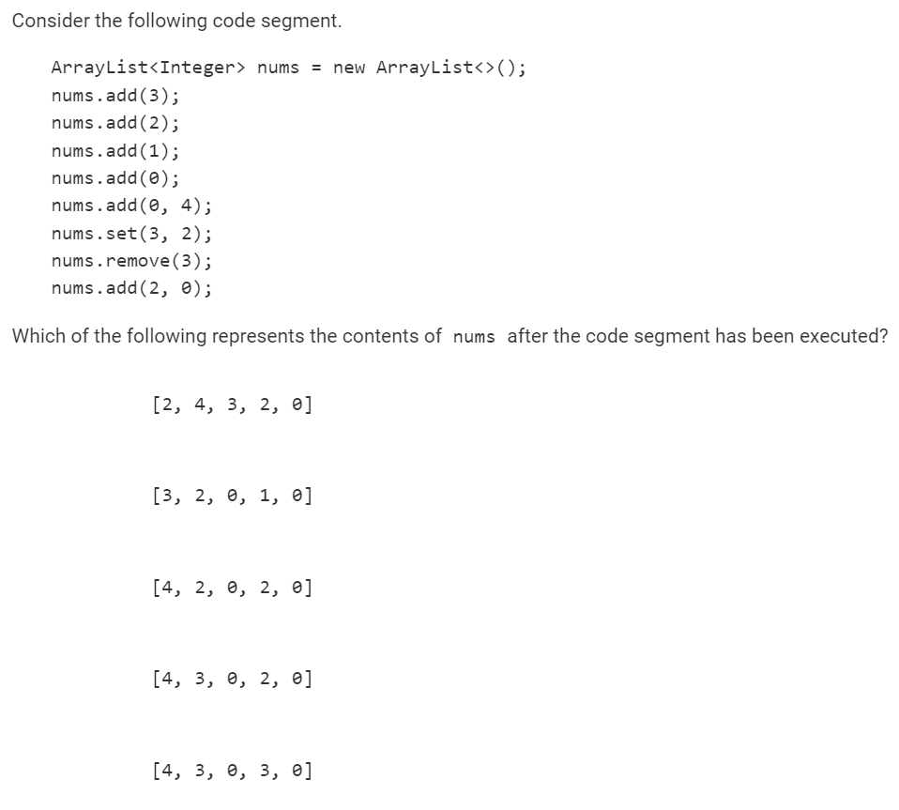

Answer = D

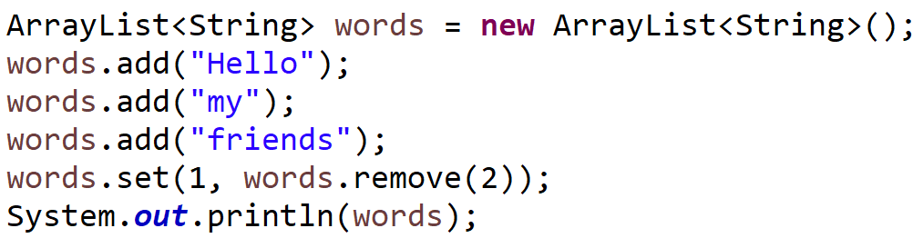

What is printed?

Answer = Hello, friends

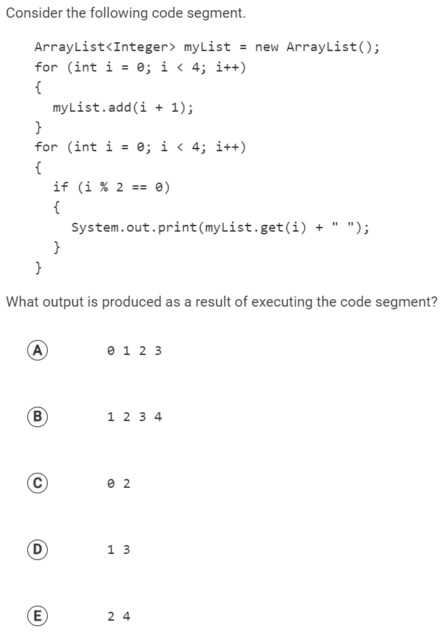

Answer = D

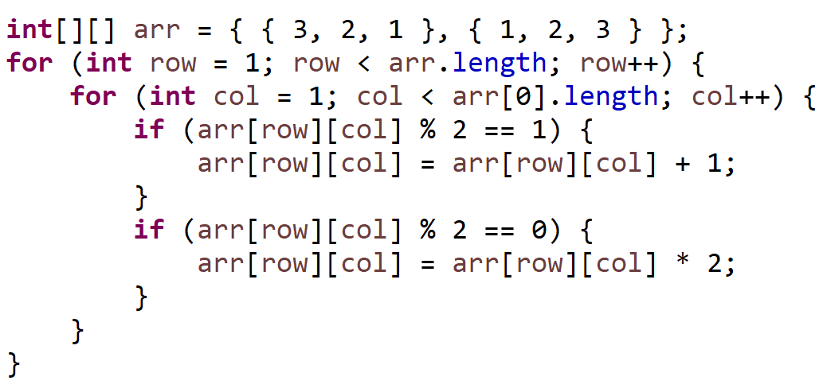

What is the value of arr after this code is run?

A. { {6, 4, 2}, {2, 4, 6}}

B. { {3, 2, 1}, {1, 4, 6}}

C. { {3, 2, 1}, {1, 4, 8}}

D. { {4, 4, 2}, {2, 4, 4}}

E. { {3, 2, 1}, {2, 4, 4}}

Answer = { {3, 2, 1}, {1, 4, 8}}

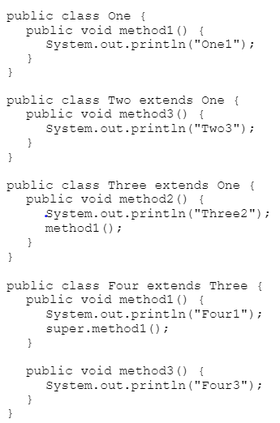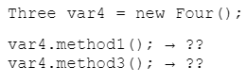

Four1 / One1

Compile Error

Consider the Mustang class:

public class Mustang extends Horse {

private int speed;

public Mustang(String name, int weight, int speed) {

super(name, weight);

this.speed = speed;

}

public int getSpeed() {

return speed;

}

}

Write a method that accepts an ArrayList of Mustangs as a parameter.

1. It should calculate and return the average speed of all of the Mustangs.
2. The owner cheats a little bit when reporting average speeds. Any mustang with a speed below 20 should be considered to have a speed of 20 when used to calculate the average.

Write a method that, given a 2D array of Strings, returns a 1D array containing how many times the word “Potato” appears in each row.

Potato Rice Apple

Potato Tomato Potato

Chocolate Coffee Potato → {1, 2, 1, 3, 0}

Potato Potato Potato

Broccoli Grape Orange